Automotive

Virtual reality games

Github- <https://github.com/Preetsingh1>

Web URL- <https://sites.google.com/view/pritpal/home>

Name: Pritpal singh

Student-ID: 100374122

Instructor Name: Dr.Abhijit Sen

Table of Contents

**Introduction**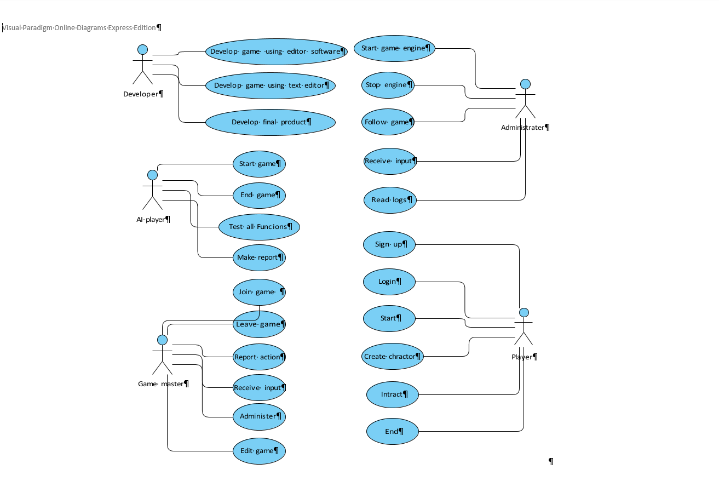

**Use Case description**

Process of developing game contain5 main steps or actor

* Developer- which do the all editing using game editor tools and then make text edition of all function by using text editing tools after these two step final product are made by developer.
* AI Player- in this process game AI system are tested and reports are made by them and they send those report to developer
* Game master- professionals player play this game and make report on it which help develop to improve game functionality
* Adminstrater- They follow the gamers and receive input from uses who play developed game and they can also read logs
* Player- these are user who play developed game